exam-result.R
ganga
2023-07-13
########################################################################
###################### Exam-Stats #####################################
########################################################################
# Adding requried libraries
library(alr4)
## Loading required package: car
## Warning: package 'car' was built under R version 4.2.2
## Loading required package: carData
## Warning: package 'carData' was built under R version 4.2.2
## Loading required package: effects
## lattice theme set by effectsTheme()
## See ?effectsTheme for details.
library(readr)
## Warning: package 'readr' was built under R version 4.2.2
library(boot)
##
## Attaching package: 'boot'
## The following object is masked from 'package:car':
##
## logit
# Importing dataset
setwd("~/Masters(GLEB)/Statistics/Exam")
m0<-read.csv("BS_day.csv")
View(m0)
str(m0)
## 'data.frame': 731 obs. of 16 variables:
## $ instant : int 1 2 3 4 5 6 7 8 9 10 ...
## $ dteday : chr "2011-01-01" "2011-01-02" "2011-01-03" "2011-01-04" ...
## $ season : int 1 1 1 1 1 1 1 1 1 1 ...
## $ yr : int 0 0 0 0 0 0 0 0 0 0 ...
## $ mnth : int 1 1 1 1 1 1 1 1 1 1 ...
## $ holiday : int 0 0 0 0 0 0 0 0 0 0 ...
## $ weekday : int 6 0 1 2 3 4 5 6 0 1 ...
## $ workingday: int 0 0 1 1 1 1 1 0 0 1 ...
## $ weathersit: int 2 2 1 1 1 1 2 2 1 1 ...
## $ temp : num 0.344 0.363 0.196 0.2 0.227 ...
## $ atemp : num 0.364 0.354 0.189 0.212 0.229 ...
## $ hum : num 0.806 0.696 0.437 0.59 0.437 ...
## $ windspeed : num 0.16 0.249 0.248 0.16 0.187 ...
## $ casual : int 331 131 120 108 82 88 148 68 54 41 ...
## $ registered: int 654 670 1229 1454 1518 1518 1362 891 768 1280 ...
## $ count : int 985 801 1349 1562 1600 1606 1510 959 822 1321 ...
# According to do our analysis i think removing the variables like:-instant,dteday,
# yr,mnth,weekday and even causal and registerd because sum of the both is the count
# i think its better to do the analysis removing this variables.
# Lets visualize the data
pairs(count~season+holiday+workingday+weathersit+atemp+temp+hum+windspeed,m0)
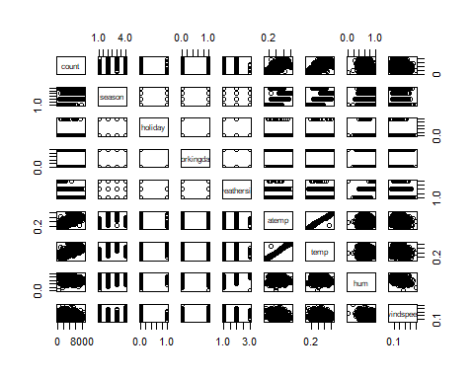
# according to the marginal plots i see that season, holiday,workingday and weathersit are
# categorical variables.atemp and temps are linearly related to count and i can also see
# there is a strong correlation between atemp and temp. and humidity is may be linearly related but
# that linearlty is depends on the leverage point(i have to check whether its influential or not)
# also its left assymetric and likewise windspeed also have some influential points.
weather<-as.factor(m0$weathersit)
sea<-as.factor(m0$season)
holi<-as.factor(m0$holiday)
working<-as.factor(m0$workingday)
m1<-lm(count~sea+holi+working+weather+temp+hum+windspeed,m0)
dim(m0)
## [1] 731 16
vif(m1)
## GVIF Df GVIF^(1/(2*Df))
## sea 3.511401 3 1.232859
## holi 1.071473 1 1.035120
## working 1.078095 1 1.038314
## weather 1.781058 2 1.155233
## temp 3.371035 1 1.836038
## hum 1.873656 1 1.368816
## windspeed 1.186944 1 1.089470
summary(m1)
##
## Call:
## lm(formula = count ~ sea + holi + working + weather + temp +
## hum + windspeed, data = m0)
##
## Residuals:
## Min 1Q Median 3Q Max
## -3768.9 -918.2 -262.0 1068.1 4152.0
##
## Coefficients:
## Estimate Std. Error t value Pr(>|t|)
## (Intercept) 3075.8 349.5 8.802 < 2e-16 ***
## sea2 918.4 178.3 5.150 3.37e-07 ***
## sea3 465.5 235.3 1.979 0.0483 *
## sea4 1495.4 152.1 9.832 < 2e-16 ***
## holi1 -598.8 296.5 -2.020 0.0438 *
## working1 100.9 106.9 0.944 0.3455
## weather2 -234.9 127.5 -1.842 0.0658 .
## weather3 -1945.2 326.2 -5.964 3.87e-09 ***
## temp 6181.0 480.2 12.871 < 2e-16 ***
## hum -2605.7 460.1 -5.663 2.15e-08 ***
## windspeed -3301.0 673.1 -4.904 1.16e-06 ***
## ---
## Signif. codes: 0 '***' 0.001 '**' 0.01 '*' 0.05 '.' 0.1 ' ' 1
##
## Residual standard error: 1294 on 720 degrees of freedom
## Multiple R-squared: 0.5602, Adjusted R-squared: 0.5541
## F-statistic: 91.72 on 10 and 720 DF, p-value: < 2.2e-16
residualPlots(m1)
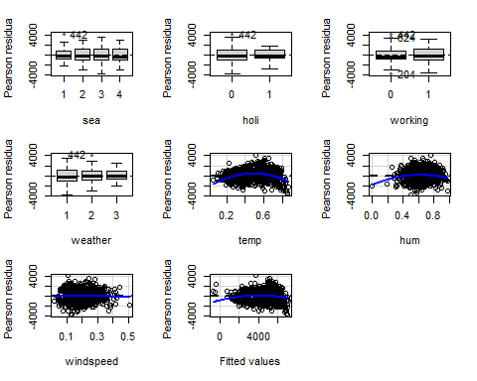
## Test stat Pr(>|Test stat|)
## sea
## holi
## working
## weather
## temp -9.6207 < 2.2e-16 ***
## hum -3.4517 0.0005896 ***
## windspeed -0.3504 0.7261680
## Tukey test -3.4641 0.0005320 ***
## ---
## Signif. codes: 0 '***' 0.001 '**' 0.01 '*' 0.05 '.' 0.1 ' ' 1
m3<-lm(count~sea+holi+working+weather+log(temp)+hum+I(hum^2)+windspeed,m0)
residualPlots(m3)
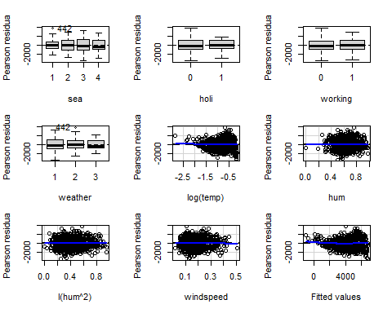
## Test stat Pr(>|Test stat|)
## sea
## holi
## working
## weather
## log(temp) 0.2061 0.8368
## hum 0.0150 0.9880
## I(hum^2) 0.3009 0.7636
## windspeed -0.1848 0.8534
## Tukey test 1.2496 0.2114
powerTransform(count~sea+holi+working+weather+I(temp*windspeed)+hum+I(hum^2),m0)
## Estimated transformation parameter
## Y1
## 0.6592546
ncvTest(m3)
## Non-constant Variance Score Test
## Variance formula: ~ fitted.values
## Chisquare = 26.19541, Df = 1, p = 3.0855e-07
ncvTest(m3,~sea)
## Non-constant Variance Score Test
## Variance formula: ~ sea
## Chisquare = 17.70019, Df = 3, p = 0.00050712
ncvTest(m3,~holi)
## Non-constant Variance Score Test
## Variance formula: ~ holi
## Chisquare = 0.06525784, Df = 1, p = 0.79837
ncvTest(m3,~working)
## Non-constant Variance Score Test
## Variance formula: ~ working
## Chisquare = 2.459703, Df = 1, p = 0.1168
ncvTest(m3,~weather)
## Non-constant Variance Score Test
## Variance formula: ~ weather
## Chisquare = 4.162922, Df = 2, p = 0.12475
ncvTest(m3,~log(temp))
## Non-constant Variance Score Test
## Variance formula: ~ log(temp)
## Chisquare = 21.82218, Df = 1, p = 2.9912e-06
ncvTest(m3,~hum)
## Non-constant Variance Score Test
## Variance formula: ~ hum
## Chisquare = 0.53694, Df = 1, p = 0.4637
ncvTest(m3,~I(hum^2))
## Non-constant Variance Score Test
## Variance formula: ~ I(hum^2)
## Chisquare = 1.066114, Df = 1, p = 0.30182
ncvTest(m3,~windspeed)
## Non-constant Variance Score Test
## Variance formula: ~ windspeed
## Chisquare = 1.526061, Df = 1, p = 0.2167
pt1<-powerTransform(count~sea+holi+working+weather+I(temp*windspeed)+hum+I(hum^2),m0)
summary(pt1)
## bcPower Transformation to Normality
## Est Power Rounded Pwr Wald Lwr Bnd Wald Upr Bnd
## Y1 0.6593 0.66 0.5496 0.7689
##
## Likelihood ratio test that transformation parameter is equal to 0
## (log transformation)
## LRT df pval
## LR test, lambda = (0) 234.8489 1 < 2.22e-16
##
## Likelihood ratio test that no transformation is needed
## LRT df pval
## LR test, lambda = (1) 31.96621 1 1.5688e-08
m4<-lm(I(count^0.6592546)~sea+holi+working+weather+log(temp)+hum+I(hum^2)+windspeed,m0)
residualPlots(m4)
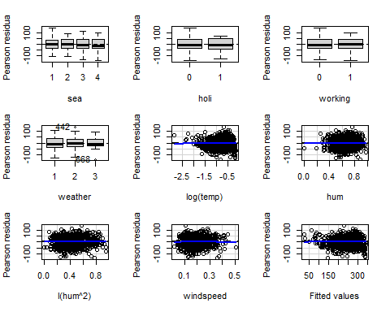
## Test stat Pr(>|Test stat|)
## sea
## holi
## working
## weather
## log(temp) -0.4773 0.6333
## hum -0.1390 0.8895
## I(hum^2) 0.5755 0.5651
## windspeed -0.4250 0.6710
## Tukey test -0.1282 0.8980
ncvTest(m4)
## Non-constant Variance Score Test
## Variance formula: ~ fitted.values
## Chisquare = 3.17967, Df = 1, p = 0.07456
ncvTest(m4,~sea)
## Non-constant Variance Score Test
## Variance formula: ~ sea
## Chisquare = 3.329899, Df = 3, p = 0.3435
ncvTest(m4,~holi)
## Non-constant Variance Score Test
## Variance formula: ~ holi
## Chisquare = 0.6734153, Df = 1, p = 0.41186
ncvTest(m4,~working)
## Non-constant Variance Score Test
## Variance formula: ~ working
## Chisquare = 3.290195, Df = 1, p = 0.069695
ncvTest(m4,~weather)
## Non-constant Variance Score Test
## Variance formula: ~ weather
## Chisquare = 0.7002962, Df = 2, p = 0.70458
ncvTest(m4,~log(temp))
## Non-constant Variance Score Test
## Variance formula: ~ log(temp)
## Chisquare = 5.458236, Df = 1, p = 0.019476
ncvTest(m4,~hum)
## Non-constant Variance Score Test
## Variance formula: ~ hum
## Chisquare = 0.02500954, Df = 1, p = 0.87434
ncvTest(m4,~I(hum^2))
## Non-constant Variance Score Test
## Variance formula: ~ I(hum^2)
## Chisquare = 0.006118299, Df = 1, p = 0.93765
ncvTest(m4,~windspeed)
## Non-constant Variance Score Test
## Variance formula: ~ windspeed
## Chisquare = 0.003683563, Df = 1, p = 0.9516
B1<- Boot(m4,R=999)
summary(B1)
##
## Number of bootstrap replications R = 999
## original bootBias bootSE bootMed
## (Intercept) 310.9844 3.766835 33.0343 311.9127
## sea2 30.7909 -0.113563 6.9896 30.5090
## sea3 18.5284 -0.053028 8.6255 18.7451
## sea4 51.2997 0.094958 5.6673 51.1940
## holi1 -26.4332 0.115376 11.8575 -25.9266
## working1 3.5707 0.157970 4.0372 3.8347
## weather2 -4.8856 -0.255557 4.6015 -5.0124
## weather3 -63.7226 0.024369 15.2703 -63.7866
## log(temp) 108.3880 0.093574 7.1366 108.5556
## hum 232.3427 -12.469012 97.8007 224.5221
## I(hum^2) -287.2946 10.195314 79.8663 -278.4874
## windspeed -136.1542 -0.312093 24.7423 -136.3927
confint(B1)
## Bootstrap bca confidence intervals
##
## 2.5 % 97.5 %
## (Intercept) 251.5410796 382.171666
## sea2 17.9998047 45.620092
## sea3 0.8480527 35.180450
## sea4 40.4292937 62.611727
## holi1 -51.0480156 -5.528647
## working1 -4.9129867 10.956964
## weather2 -14.6988815 3.959085
## weather3 -93.4270908 -34.067398
## log(temp) 93.6198885 121.595865
## hum 36.6324719 411.875848
## I(hum^2) -446.5126167 -133.161445
## windspeed -190.1030644 -86.847486
hist(B1)
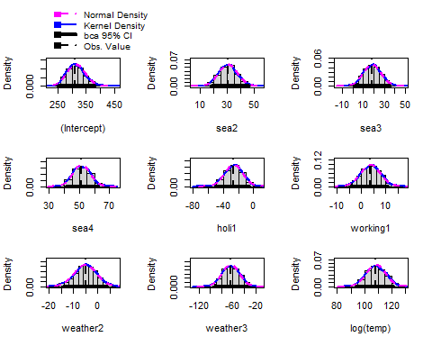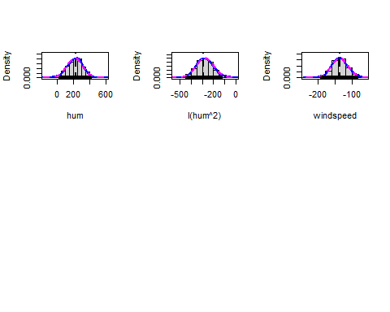
outlierTest(m4)
## No Studentized residuals with Bonferroni p < 0.05
## Largest |rstudent|:
## rstudent unadjusted p-value Bonferroni p
## 668 -3.050789 0.0023665 NA
plot(m4)
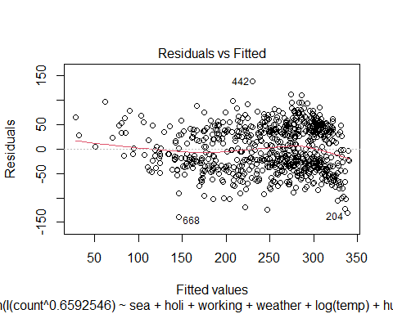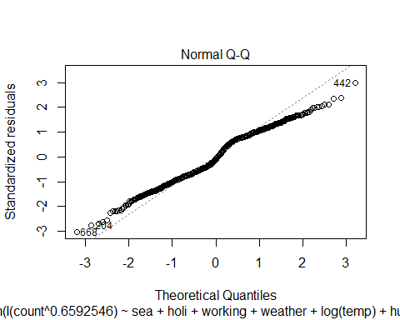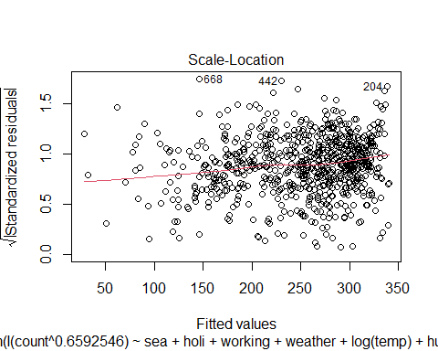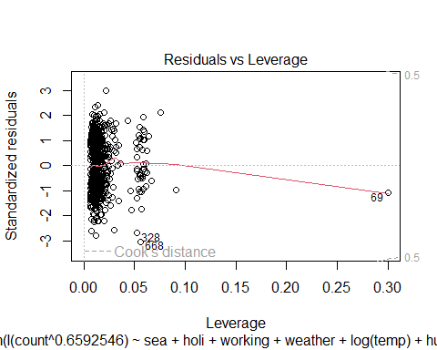
influenceIndexPlot(m4)
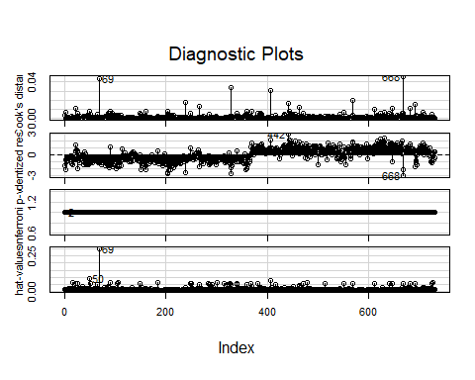
max(cooks.distance(m4))
## [1] 0.0456928
pairs(I(count^0.6592546 )~sea+holi+working+weather+log(temp)+hum+I(hum^2)+windspeed,m0)
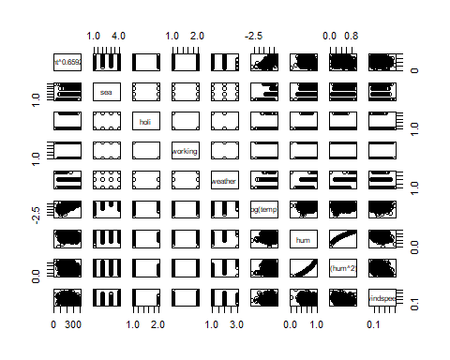
summary(m4)
##
## Call:
## lm(formula = I(count^0.6592546) ~ sea + holi + working + weather +
## log(temp) + hum + I(hum^2) + windspeed, data = m0)
##
## Residuals:
## Min 1Q Median 3Q Max
## -138.684 -35.665 -4.818 38.451 138.736
##
## Coefficients:
## Estimate Std. Error t value Pr(>|t|)
## (Intercept) 310.984 29.788 10.440 < 2e-16 ***
## sea2 30.791 6.518 4.724 2.78e-06 ***
## sea3 18.528 7.935 2.335 0.01981 *
## sea4 51.300 5.702 8.997 < 2e-16 ***
## holi1 -26.433 10.799 -2.448 0.01461 *
## working1 3.571 3.894 0.917 0.35941
## weather2 -4.886 4.726 -1.034 0.30164
## weather3 -63.723 13.356 -4.771 2.22e-06 ***
## log(temp) 108.388 6.839 15.848 < 2e-16 ***
## hum 232.343 88.000 2.640 0.00846 **
## I(hum^2) -287.295 71.858 -3.998 7.05e-05 ***
## windspeed -136.154 24.543 -5.548 4.07e-08 ***
## ---
## Signif. codes: 0 '***' 0.001 '**' 0.01 '*' 0.05 '.' 0.1 ' ' 1
##
## Residual standard error: 47.06 on 719 degrees of freedom
## Multiple R-squared: 0.6263, Adjusted R-squared: 0.6205
## F-statistic: 109.5 on 11 and 719 DF, p-value: < 2.2e-16
boxplot(count~holiday,m0)
